Day 24 – 08/08/2025

// Task001: Abstract Factory design pattern  
  
package Day24.AbstractFactory;  
  
public class MobileFactory {  
 private final Brand brand;  
  
 public MobileFactory(Brand brand){  
 this.brand = brand;  
 }  
  
 public Mobile createMobile(String modelName){  
 return brand.createModel(modelName);  
 }  
  
 public static void main(String[] args) {  
 Brand apple = new Apple();  
 MobileFactory appleFactory = new MobileFactory(apple);  
 Mobile iPhone16 = appleFactory.createMobile("iPhone16");  
 iPhone16.text();  
 }  
}

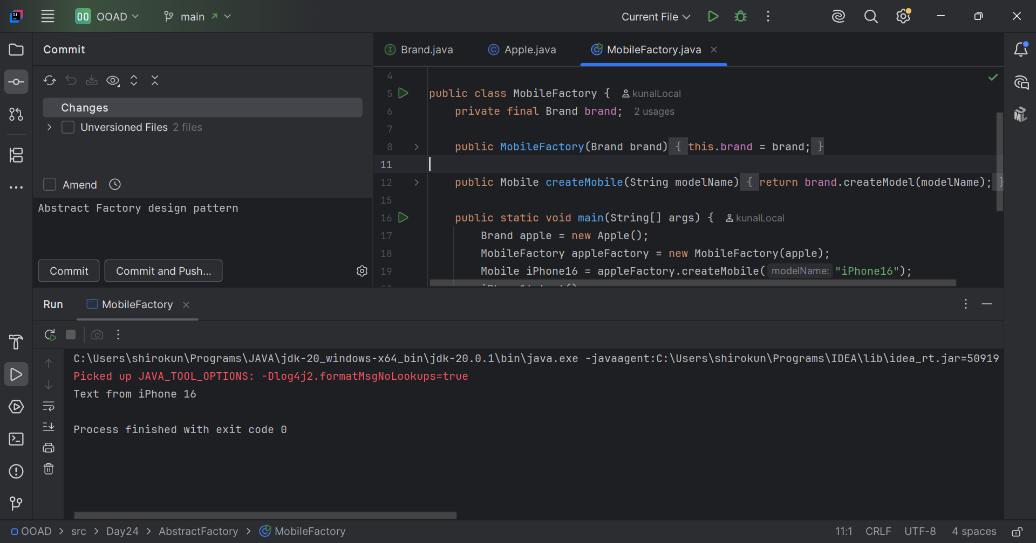

// Task003: Prototype.  
  
package Day24.Prototype;  
  
public class Theme {  
 public static void main(String[] args) {  
 Colors blackConcrete = new BlackConcrete("Black");  
 Colors blackClone = blackConcrete.clones();  
 blackClone.setName("Dark");  
 System.*out*.println(blackConcrete.getName()+  
 " is "+blackClone.getName()+" color.");  
 }  
}

